**Ideation Phase**

**Empathize & Discover**

| Date | 31 January 2025 |
| --- | --- |
| Team ID | SWTID1743511769 |
| Project Name | TravelGram(Social media for travel enthusiast) |
| Maximum Marks | 4 Marks |

**Empathy Map Canvas:**

An Empathy Map Canvas is a collaborative tool that allows teams to build a deeper, shared understanding of users. It visually captures what users say, think, do, and feel while interacting with a product or trying to solve a particular problem. This structured exploration of the user’s experience helps teams uncover hidden needs, pain points, motivations, and emotional responses that may not be immediately obvious.

Creating an empathy map pushes us to shift our perspective from "what we think users want" to truly stepping into the user's shoes. It allows designers, developers, and stakeholders to stay user-focused throughout the ideation and development process.

This tool is especially effective when developing user-centric digital solutions, such as mobile applications, travel platforms, or food delivery services, as it bridges the gap between assumptions and real user behavior.

**Example:**To design a seamless and personalized travel experience, we used the Empathy Map Canvas to understand our primary users — frequent travelers and first-time travel planners. The mapping session helped identify key areas such as:

* **What they SAY:** “I want to book everything in one place — flights, hotels, and packages.”
* **What they THINK:** “Is this agency trustworthy? What if there’s a last-minute issue?”
* **What they DO:** Compare multiple platforms, read reviews, and ask friends before booking.
* **What they FEEL:** Anxious about travel planning, excited about exploring, frustrated by slow support or unclear pricing.

By using this framework, we ensured that our design decisions were aligned with the actual needs, goals, and pain points of our users — ultimately leading to a more impactful and intuitive travel experience.

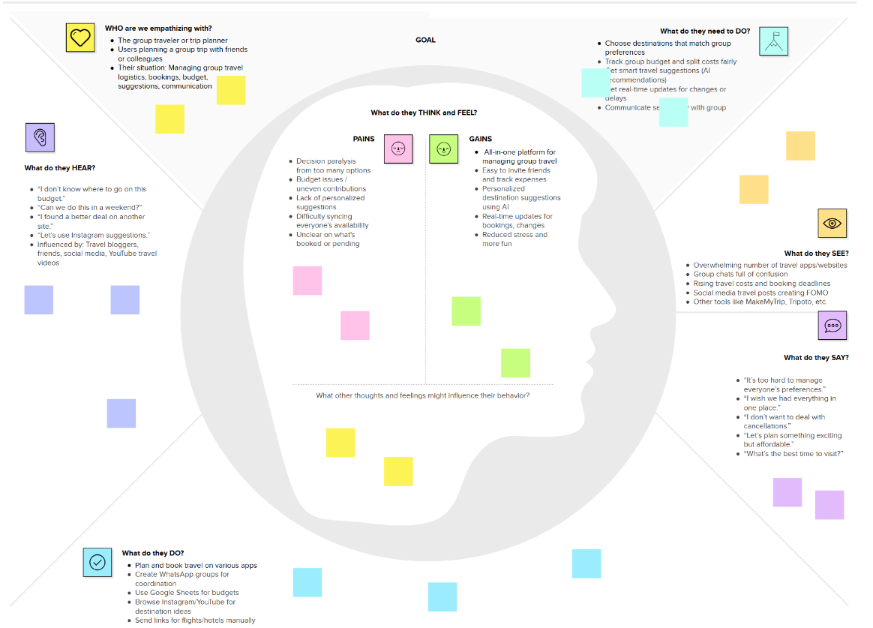

Link: <https://app.mural.co/t/travelgram7894/m/travelgram7894/1743874709113/b621784a8887f7365db647b7df481d30465e0d0d?sender=u1e90317ebed16c4cd93d8252>